**Documentation:**

Step 2 Implementations:

Note: Despite being able to make requests via browser, we haven’t found a way to modify get requests coming from the browser (ie: changing header fields, altering text), so some testing is done within the terminal. However, any returned html messages have been tested independently before implementation.

400 Bad Request:

Sending any get request where the beginning of the request is not ‘GET /’ will result in a ‘400 Bad Request’ message being displayed.

Request:

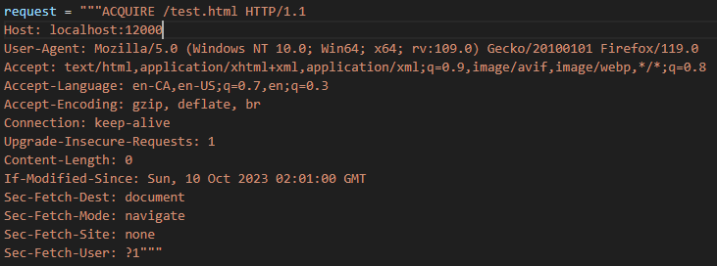

Client Result:

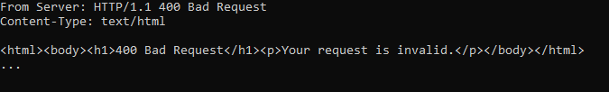

403 Forbidden:

We decided to handle the forbidden code with a forbidden directory as opposed to authentication headers because it seemed more streamlined to implement and easier to test. Attempting to access any file in the directory ./forbidden will return a webpage with ‘403 Forbidden’:

Request:

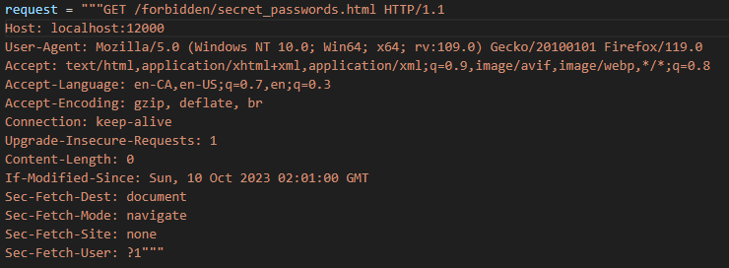

Client Result:

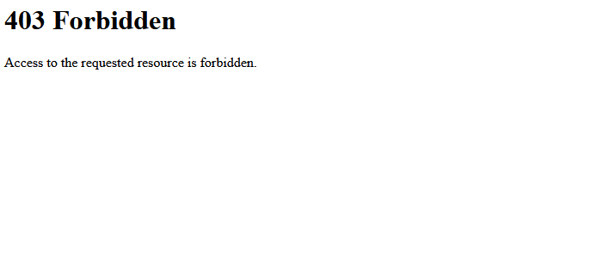

411 Length Required:

Any request that doesn’t contain the header ‘Content-Length’ will return a ‘411 Length Required’ status message:

Request:

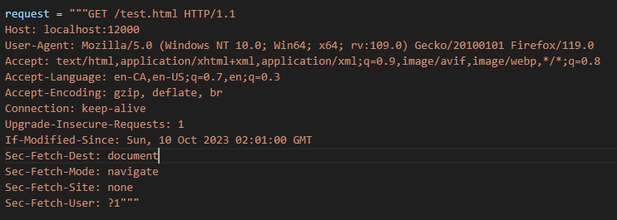

Client Result:

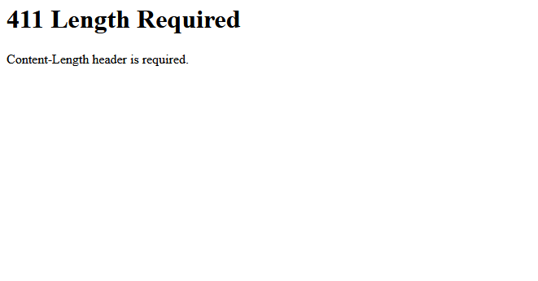

404 Not Found:

Simply enough, if the specified path in the GET request is not found in the server directory (ie: filepath does not exist), then a ‘404 Not Found’ status message is shown to the client:

Request:

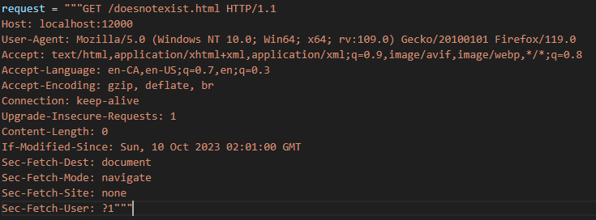

Client Result:



304 Not Modified:

For simplicity in implementing this status code, we hardcoded a datetime object with a specific date as the web server’s ‘last modified date’, equal to November 30th, 2023, and used it to compare against the requests ‘If-Modified-Since’ conditional header value. If the header’s date was before the web server’s ‘last modified date’, then the client received the web page along with a ‘200 OK’ status, but if the header’s date was after, the client would receive a ‘304 Not Modified’ status code in lieu of the web browser loading the webpage from the cache and displaying it.

Request (If-Modified-Since before the server’s last modified date):

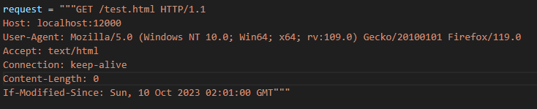

Client Result:

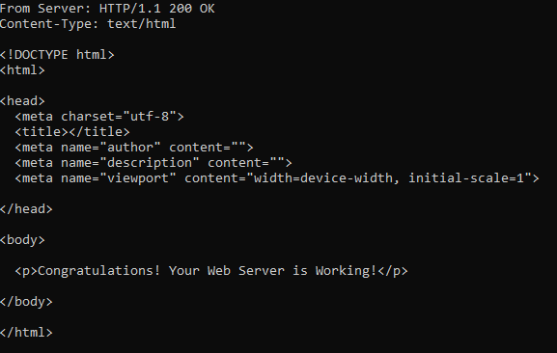

Request (If-Modified-Since after the server’s last modified date):

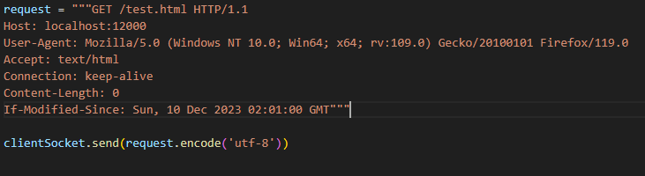

Client Result:

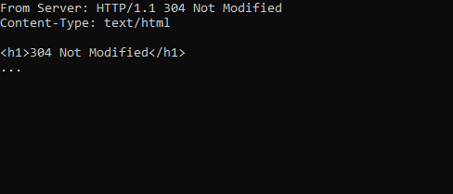

200 OK:

Finally, if there are no discrepancies in the GET request as mentioned above, the server will return the requested webpage

Request:

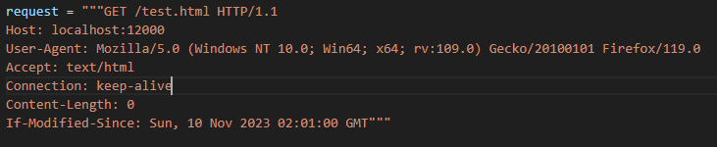

Client Result:



Request:

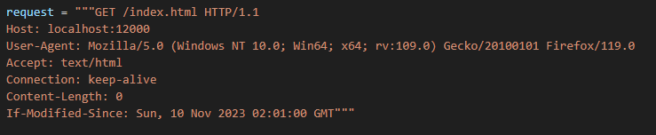

Client Result:

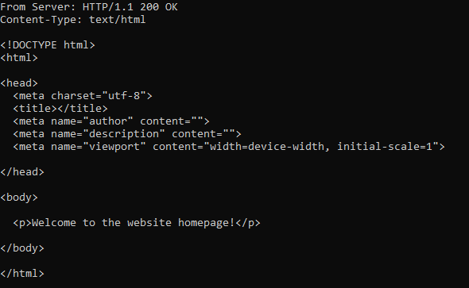

Step 3 Implementation: